COURSE NAME

TWU Online

Dec 10, 2025

# Welcome

This is the course book for **COURSE NUMBER**. This book is divided into thematic units of study to help you engage with the materials. The course resources and learning activities are designed not only to help prepare you for the course assessments, but also to give you opportunities to practice various skills.

**<Begin note>**

*Note:* Please read the full course syllabus located on the Course Home page in Moodle. It includes key information about the course schedule, assignments, and policies.

**<End note>**

## Course Activities

Below is some key information on features you may see throughout the course.

**<Begin learning-activity>**

**Estimated Time:**

This box will prompt you to engage in course concepts by:

* Viewing resources and reflecting on your experience and/or learning.
* Checking your understanding to make sure you are ready for what follows. Ways to check your learning might include self-check quizzes or questions for discussion.

*Note:* Working through course activities will help you to meet the learning outcomes and successfully complete your assessments.

**<End learning-activity>**

# 1. Unit 1 Title

## 1.1 Overview

Welcome to [COURSE]

### Topics

This unit is divided into the following topics: 1. 2. 3.

### Unit Learning Outcomes

When you have completed this unit, you will be able to:

* Describe…
* Contrast…
* Analyze…
* Determine…
* Create…

### Learning Activities

Here is a list of learning activities that will benefit you in completing this unit. You may find it useful for planning your work.

**<Begin learning-activity>**

**Estimated Time:**

1. Read…
2. Watch…
3. Explore…
4. Complete the ungraded quiz.

*Note*: Working through course activities will help you to meet the learning outcomes and successfully complete your assessments.

**<End learning-activity>**

### Assessment

Please see the Assessment section in Moodle for assignment details.

### Resources

Here are the resources you will need to complete this unit.

* (Textbook)
* Other online resources will be provided in the unit.

## 1.2 Title for Topic 1

We begin Unit 1…

*(add content)*

### 1.2.1 Activity: Title (e.g. Read, Reflect and View)

**<Begin learning-activity>**

**Estimated Time:** 00 minutes

*(add content)*

View the following resources about …

Next, watch the following videos that illustrate…

**Questions to Consider**

After completing the activities above, consider the following questions:

* This is a question?

**<End learning-activity>**

## 1.3 Title for Topic 2

*(add content)*

### 1.3.1 Activity: Title

**<Begin learning-activity>**

**Estimated Time:** 00 minutes

e.g. Case study

*(add content)*

**<Begin note-with-icon>**

Note that you may be asked to review this case or similar cases in your class discussion groups. You may want to prepare by relating the case to your readings. Specifically, identify the ethical issues and terms to help explain the case.

**<End note-with-icon>**

**<End learning-activity>**

## 1.4 Title for Topic 3

*(add content)*

…

### 1.4.1 Activity: Title

**<Begin learning-activity>**

**Estimated Time:** 00 minutes

*(See* [*Assessment ideas*](https://multi-access.twu.ca/assessment/assessment-ideas) *for other ways to engage students in the topics.)*

**<End learning-activity>**

## Summary

In this first unit, you have had the opportunity to learn about…

*(add content)*

**<Begin checking-your-learning>**

Before you move on to the next unit, you may want to check that you are able to:

* Describe…
* Contrast…
* Analyze…
* Determine…
* Create…

**<End checking-your-learning>**

## References

# 2. A title for Unit 2

# 3. A title for Unit 3

# 4. A title for Unit 4

# 5. A title for Unit 5

# 6. A title for Unit 6

# Quarto Cheatsheet

Below are some examples of content that can be used in course production.

### Notes

There are 2 options for notes, notes with or without icons.

#### Note with an icon

**<Begin note-with-icon>**

*Note:* A note **with** an icon

**<End note-with-icon>**

#### Note without an Icon

**<Begin note>**

*Note:* A note **without** an icon

**<End note>**

### Blockquotes

“Your brand is what people say about you when you’re not in the room.” ***– Jeff Bezos***

### Accordions

This is an Accordion.

An accordion may contain extra content such as worked examples or sample answers. Accordions should be used sparingly.

### Images

Images are handled differently depending on if they are fig-images (figures) or dec-images (decorative).

#### Fig-image

* Should contain a caption
* Should have a unique fig id (*“#fig-u1_1”*)
* You can reference any fig-image by its unique fig id from anywhere in the course
  + (example: *@fig-u1_1*)
* Should contain alt text
* Should contain source metadata (at least source-text)
* May use a lightbox.
  + Adding a lightbox makes the image expandable with a click or tap.

**<Begin figure>**

**Figure ID:** #fig-image  
**Caption:** This is a caption for a fig-image  
**Columns:**

**<Begin fig-image>**

**Figure ID:** u1_1  
**Caption:**   
**Alt Text:** Cat Sitting on a Wooden Table  
**Has Lightbox:** yes  
**Source Text:**   
**Source URL:**   
**Author:**   
**Author URL:**   
**Copyright:**   
**License Text:**   
**License URL:**

|  |
| --- |
|  |

**<End fig-image>**

**<End figure>**

*Source:* Garvin, D. A, & Roberto, M. A. (2001). What you don’t know about making decisions. *Harvard Business Review, 79*(8)

**<Begin figure>**

**Figure ID:** #fig-image1  
**Caption:**   
**Columns:**

**<Begin dec-image>**

**Alt Text:** Cat Sitting on a Wooden Table  
**Has Lightbox:** yes  
**Source Text:**   
**Source URL:**   
**Author:**   
**Author URL:**   
**Copyright:**   
**License Text:**   
**License URL:**

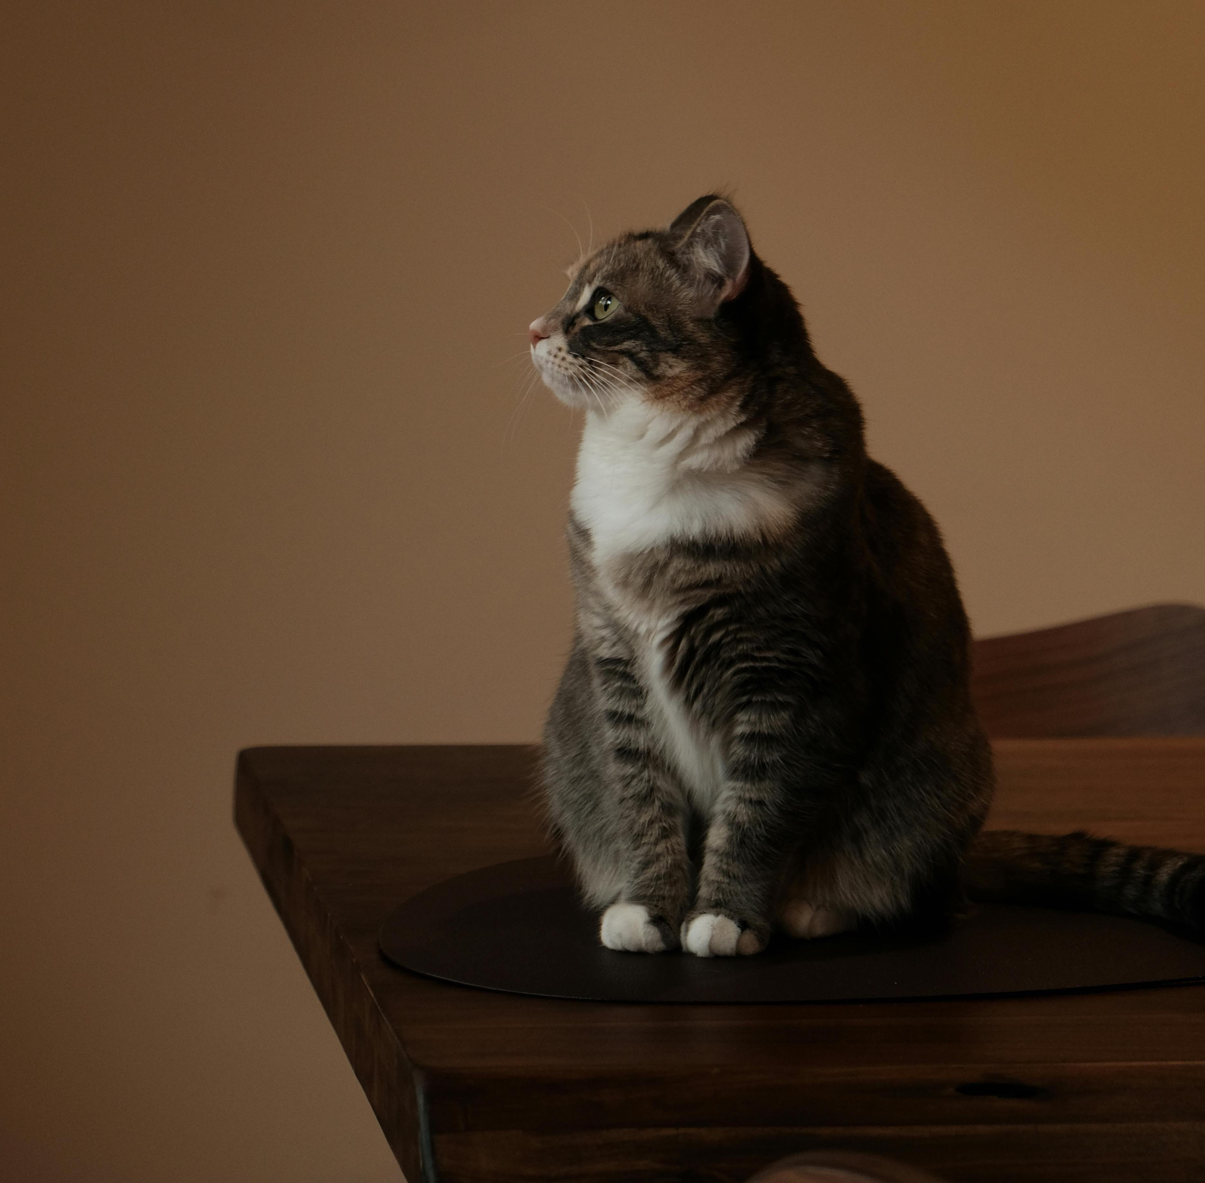

**<End dec-image>**

**<End figure>**

*Source:* Garvin, D. A, & Roberto, M. A. (2001). What you don’t know about making decisions. *Harvard Business Review, 79*(8)

#### Dec-image

* Should not contain a caption
* Should not have a fig id
* Should contain alt text as ‘Decorative’
* Should contain source metadata (at least source-text)
* May use a lightbox.
  + Adding a lightbox makes the image expandable with a click or tap. Generally this is not necessary with a decorative image.

**<Begin dec-image>**

**Alt Text:** Decorative  
**Has Lightbox:** no  
**Source Text:** Delicious Fresh Croissants  
**Source URL:** <https://www.pexels.com/photo/delicious-fresh-croissants-at-sardinian-cafe-28871875/>  
**Author:** Efrem Efre  
**Author URL:** <https://www.pexels.com/@efrem-efre-2786187/>  
**Copyright:** 2024, Efrem Efre  
**License Text:** Pexels License  
**License URL:** <https://www.pexels.com/license/>

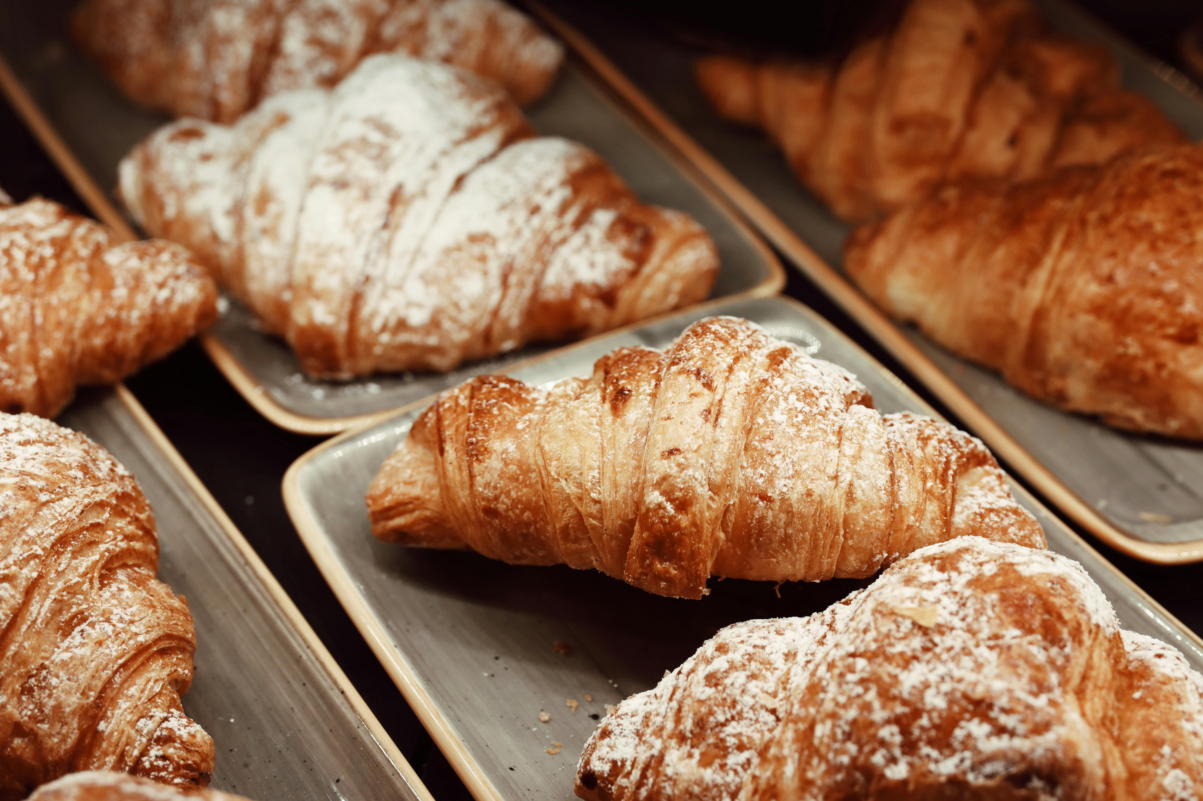

**<End dec-image>**

#### Figure Blocks

Below is a figure block containing 2 fig-images. It has a 2 column layout, so the 2 images will appear side by side.

**<Begin figure>**

**Figure ID:** #fig-block_u1_1  
**Caption:** This is the caption of the figure block  
**Columns:** 2

**<Begin fig-image>**

**Figure ID:** #fig-u1_2  
**Caption:** This is a caption for the first fig-image  
**Alt Text:** Red Tram  
**Has Lightbox:** yes  
**Source Text:** Vintage Red Tram on Streets of Prague  
**Source URL:** <https://www.pexels.com/photo/vintage-red-tram-on-streets-of-prague-28999320/>  
**Author:** Aakash Goel  
**Author URL:** <https://www.pexels.com/@ohaakash/>  
**Copyright:** 2022, Aakash Goel  
**License Text:** Pexels License  
**License URL:** <https://www.pexels.com/license/>

|  |
| --- |
|  |

**<End fig-image>**

**<Begin fig-image>**

**Figure ID:** #fig-u1_3  
**Caption:** This is a caption for the second fig-image  
**Alt Text:** Modern living room interior with furniture and assorted plants  
**Has Lightbox:** yes  
**Source Text:** Modern living room interior  
**Source URL:** <https://www.pexels.com/photo/modern-living-room-interior-with-furniture-and-assorted-plants-4740484/>  
**Author:** Ksenia Chernaya  
**Author URL:** <https://www.pexels.com/@kseniachernaya/>  
**Copyright:** 2020, Ksenia Chernaya  
**License Text:** Pexels License  
**License URL:** <https://www.pexels.com/license/>

|  |
| --- |
|  |

**<End fig-image>**

**<End figure>**

### Tables

Below is a table. All tables should be contained within a figure block. Figures containg tables should not use columns.

**<Begin figure>**

**Figure ID:** #fig-table_u1_1  
**Caption:** This is the caption for the table figure  
**Columns:**

| Month | Savings |
| --- | --- |
| January | $250 |
| February | $80 |
| March | $420 |

**<End figure>**

### Learning Activites

You can set the estimated time of an activity. If you do not set the time, the field will not display.

### Activity: Title of the Activity

**<Begin learning-activity>**

**Estimated Time:** 20 minutes

This is a learning activity containing an h5p activity. It has an estimated time set to 20 minutes.

<https://create.twu.ca/h5p/wp-admin/admin-ajax.php?action=h5p_embed&id=612>

**<Begin note>**

*Note:* This is a note within an activity.

**<End note>**

**Questions to Consider**

1. Is this a question?
2. Is this a second question?

|  |  |
| --- | --- |
|  | **Note from Production**  This is a prote. Protes (production notes) are only visible in *.qm*d or *.docx* files. |

[Watch: The Art of Choosing](https://www.youtube-nocookie.com/embed/lDq9-QxvsNU)

<https://www.youtube-nocookie.com/embed/lDq9-QxvsNU>

**<End learning-activity>**

### Case Study Example

|  |
| --- |
| It is unnumbered, so it won’t interfer with activities numbering, but display on the right hand side as part of the table of content.  This design is created for case study intention, but open to other usage. |

### Quiz Example

We create Quarto quizzes in replacement to H5P quizzes or PDF format. It is manual work, so please send in content early. For next iteration, we will add a carousell format to it.

Please note that the quiz response is not saved. Below is a shortened version. For existing course examples, see LDRS 504 [5.2.2](https://twuonline.github.io/ldrs504/u5.html#activity-team-assessment) and [5.5.1](https://twuonline.github.io/ldrs504/u5.html#activity-self-assessment-promoting-ethical-group-interactions).

**<Begin learning-activity>**

**Estimated Time:**

**Instructions:** For each statement below, rate how often you personally engage in or observe these behaviours in your groups or teams. Use this scale:

**1 = Rarely or never** **2 = Sometimes** **3 = Often** **4 = Almost always**

1. Listen carefully to others, seeking to fully understand their message, including emotions and intent, before responding.

* 1. Rarely or never
  2. Sometimes
  3. Often
  4. Almost always

2. I avoid communication that makes others feel defensive, such as criticizing or controlling language.

* 1. Rarely or never
  2. Sometimes
  3. Often
  4. Almost always

3. I am aware of my own emotions during group interactions and try to manage them constructively.

* 1. Rarely or never
  2. Sometimes
  3. Often
  4. Almost always

4. I encourage open discussion of different viewpoints, even when there is disagreement or conflict.

* 1. Rarely or never
  2. Sometimes
  3. Often
  4. Almost always

5. I welcome and respect minority opinions or dissenting views in group decisions.

* 1. Rarely or never
  2. Sometimes
  3. Often
  4. Almost always

**How to Interpret Your Results**

**Step 1: Calculate Your Average Score**

Add your scores for all 5 statements and divide them by 5 to find your average.

**Step 2: Reflect on Your Average**

| **Average Score** | **Interpretation** | **Reflection Questions** |
| --- | --- | --- |
| **3.5 – 4.0** | **Consistently Ethical** |  |
| You regularly practice behaviours that promote ethical and effective group interactions. Keep reinforcing these strengths! | What specific habits help you maintain this level? How can you support others in your group? |  |
| **2.5 – 3.4** | **Moderate Practice** |  |
| You sometimes engage in these ethical behaviours but there is room for growth. | Which areas do you notice the most inconsistency? What small changes can you make to improve? |  |
| **1.0 – 2.4** | **Needs Attention** |  |
| You rarely or only occasionally use these behaviours, which may hinder ethical group dynamics. | What barriers prevent you from practicing these behaviours? What support or resources would help you develop them? |  |

**Step 3: Look at Individual Items** Identify any statements where you scored below 3. These might be key focus areas to develop, as they represent critical aspects of ethical group interaction.

**Step 4: Set a Personal Goal** Choose one or two behaviours to focus on strengthening in your next group experience. Consider how you might apply supportive communication, emotional intelligence, or encourage minority opinions more actively.

**Reflection Questions (Optional)**

* Which of these areas do you feel strongest in?
* Which areas could you improve to promote more ethical group interactions?
* How might you practice supportive communication or encourage productive conflict in your next team meeting?

**<End learning-activity>**

### Formula Example

$$z=\frac{68−70}{12}$$

$$95\%CI=\text{mean}±\left(SE×1.96\right)$$

### Mermaid Examples

#### Flowchart

**<Begin dec-image>**

**Alt Text:**   
**Has Lightbox:** no  
**Source Text:**   
**Source URL:**   
**Author:**   
**Author URL:**   
**Copyright:**   
**License Text:**   
**License URL:**

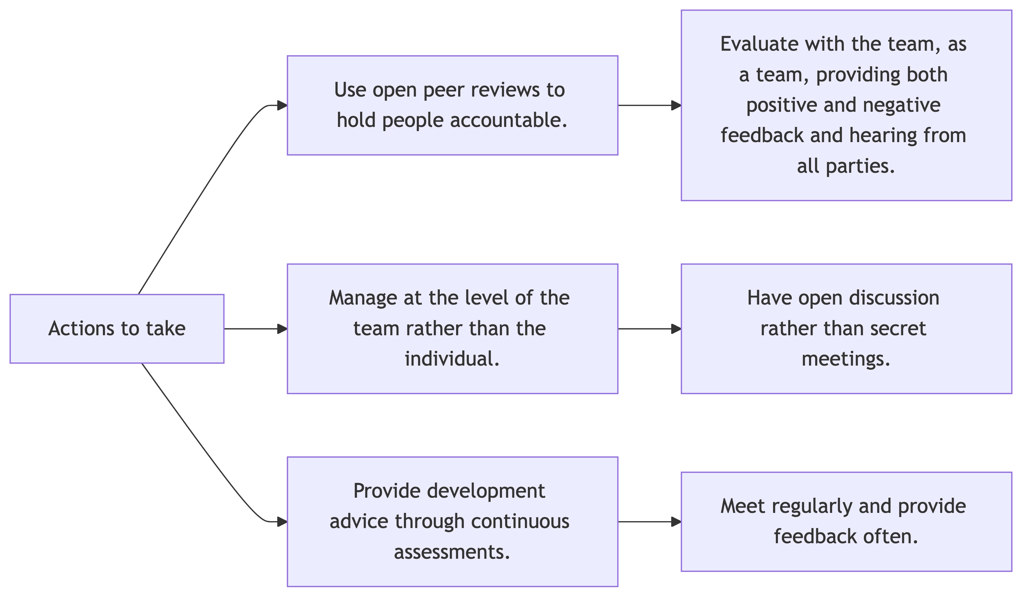

**<End dec-image>**

#### State Diagram

**<Begin dec-image>**

**Alt Text:**   
**Has Lightbox:** no  
**Source Text:**   
**Source URL:**   
**Author:**   
**Author URL:**   
**Copyright:**   
**License Text:**   
**License URL:**

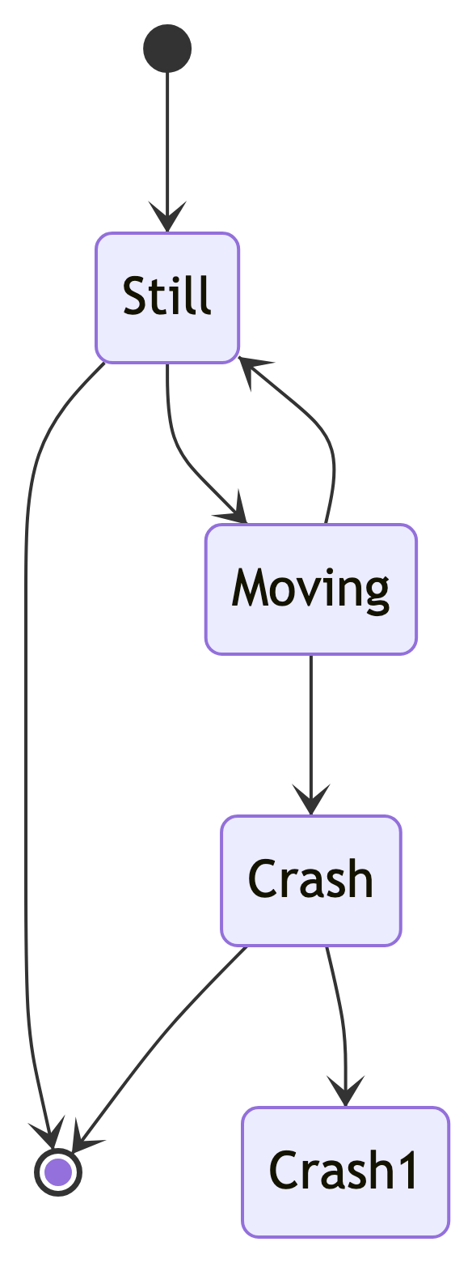

**<End dec-image>**

### Tabs

Tabs are only compatible with content displayed on Quarto site, not Moodle.

### Tab A

**<Begin dec-image>**

**Alt Text:**   
**Has Lightbox:** yes  
**Source Text:**   
**Source URL:**   
**Author:**   
**Author URL:**   
**Copyright:**   
**License Text:**   
**License URL:**



**<End dec-image>**

Artists have an uncanny ability to make things seem real. The potential for ‘trompe-l’oeil’ like this train coming out of the wall seemed as dangerous to the ancients as portraying something imperfectly and thus damaging our understanding of it. Art is out of control!

### Tab B

**<Begin dec-image>**

**Alt Text:**   
**Has Lightbox:** no  
**Source Text:**   
**Source URL:**   
**Author:**   
**Author URL:**   
**Copyright:**   
**License Text:**   
**License URL:**



**<End dec-image>**

Some ancients believed art functioned like a false front, only showing part of something or being inherently deceitful.

### Summary

**<Begin checking-your-learning>**

**Before you move on to the next unit you may want to check that you are able to:**

* Describe the place of leadership in results
* Explain the discipline of results-based leadership
* Contrast a team-based leadership style with other approaches to leadership

**<End checking-your-learning>**

# 7. Habits

## 7.1 Getting up

* Turn off alarm
* Get out of bed

## 7.2 Going to sleep

* Get in bed
* Count sheep